1.We are ranking on the google on ”1st” place for the keyword “How much does e mail marketing cost in dubai”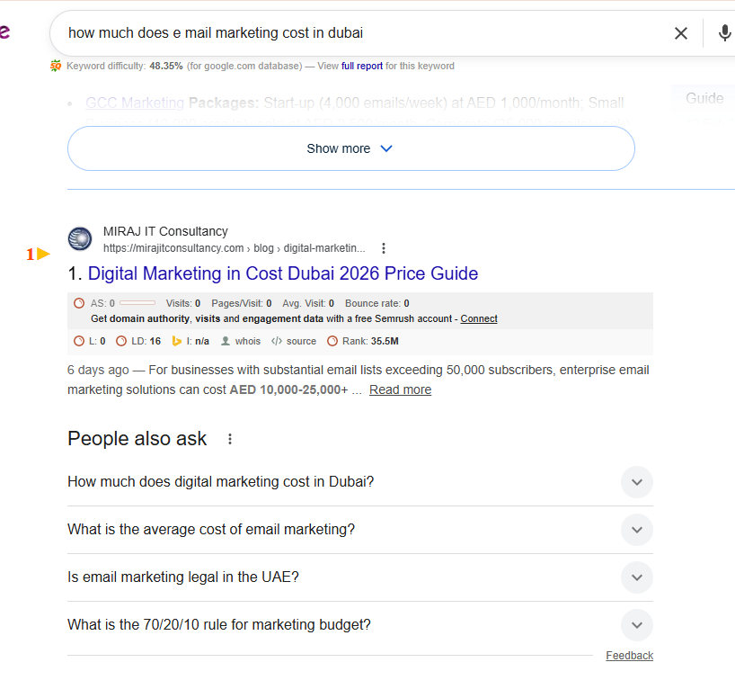

2.Also We are ranking on the AI 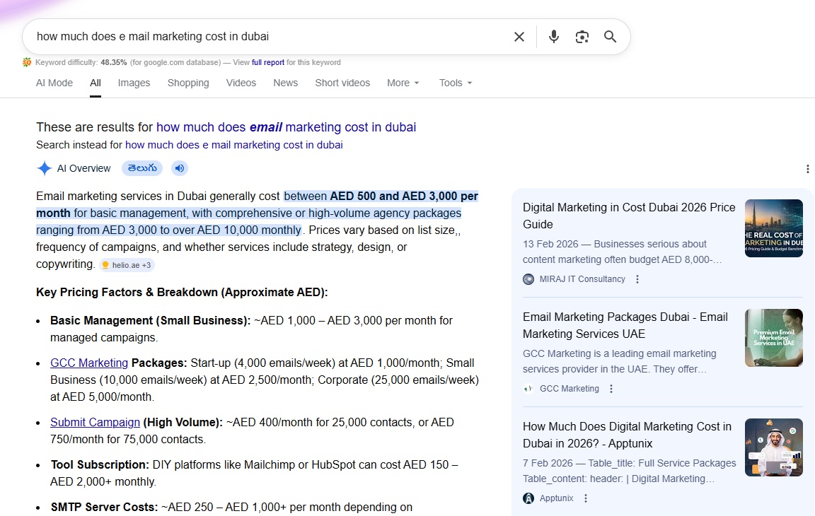

3.We are ranking on the google on ”8th” place for the keyword “Ad Spend Consultation Dubai”
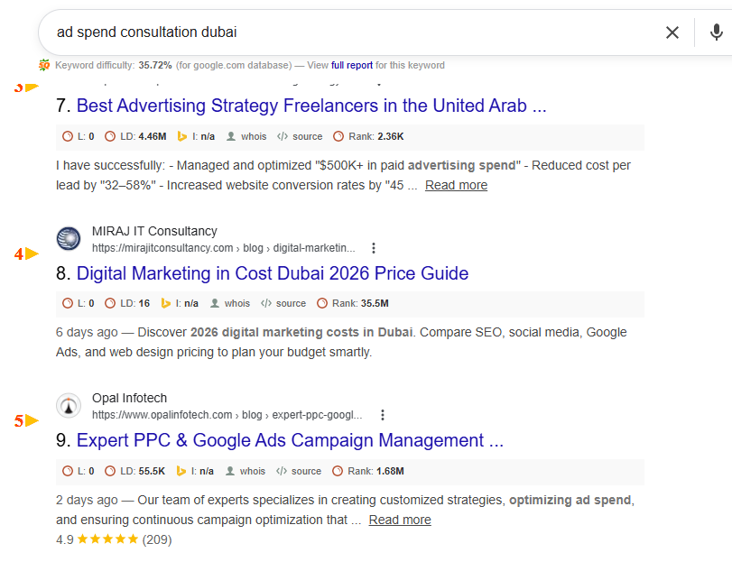

4.Also We are ranking on the AI

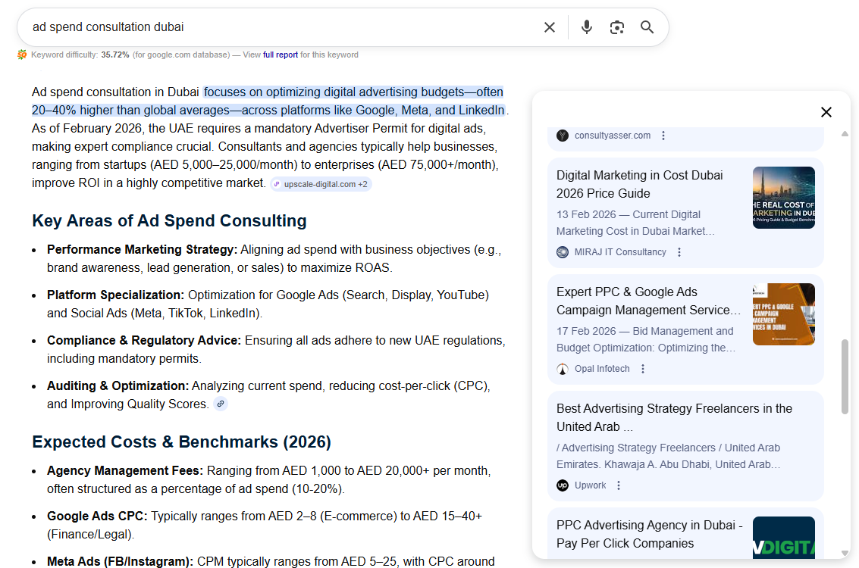

5.We are ranking on the google on ”35th” place for the keyword “Digital Marketing In UAE”

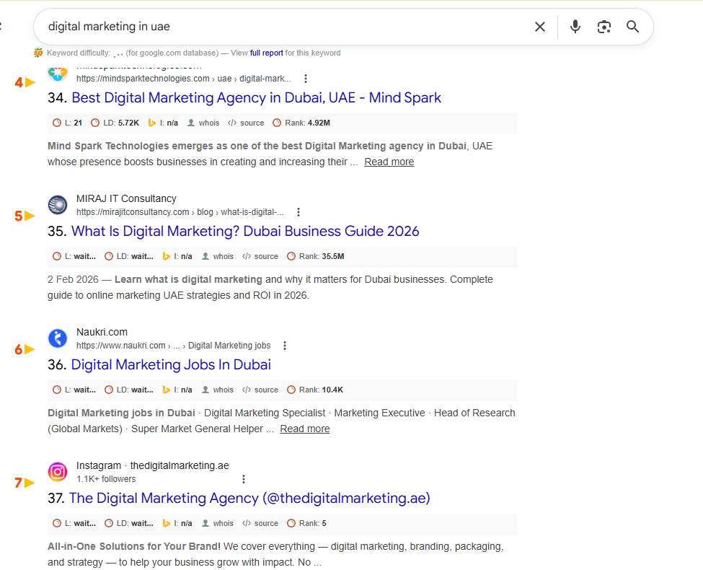

6.We are ranking on the google on ”50th” place for the keyword “Digital Marketing Emirates”

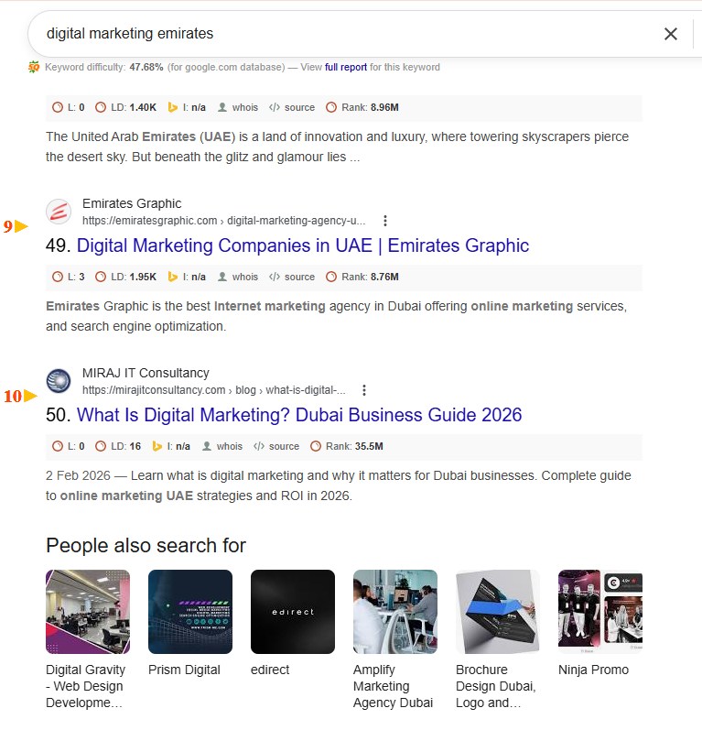

7.We are ranking on the google on ”7th” place for the keyword “#Digitalmarketingdubai”

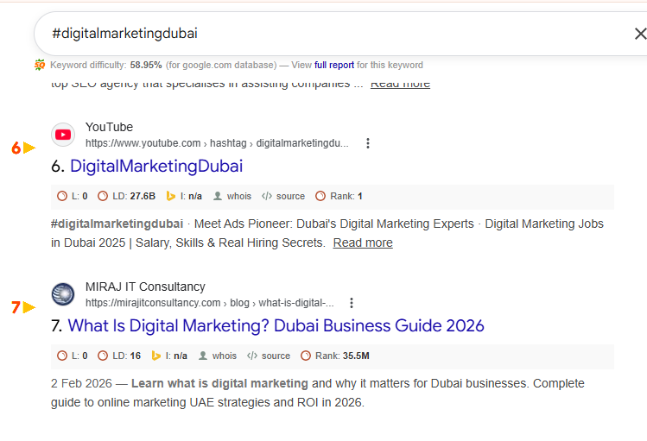
8.We are ranking on the google on ”20th” place for the keyword “marketing roadmap uae”

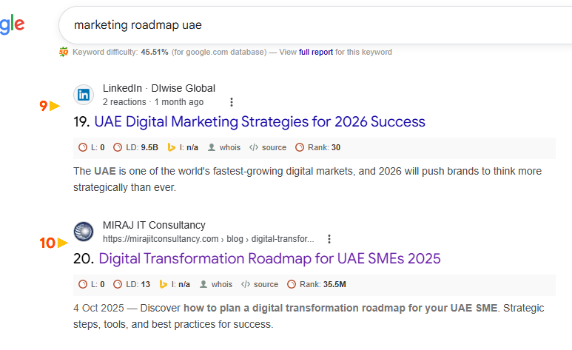

9.We are ranking on the google on ”1st” place for the keyword “digital transformation for smes uae”

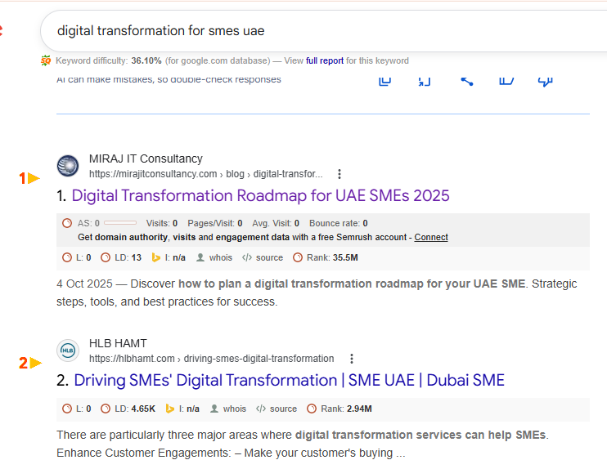
10.Also We are ranking on the AI
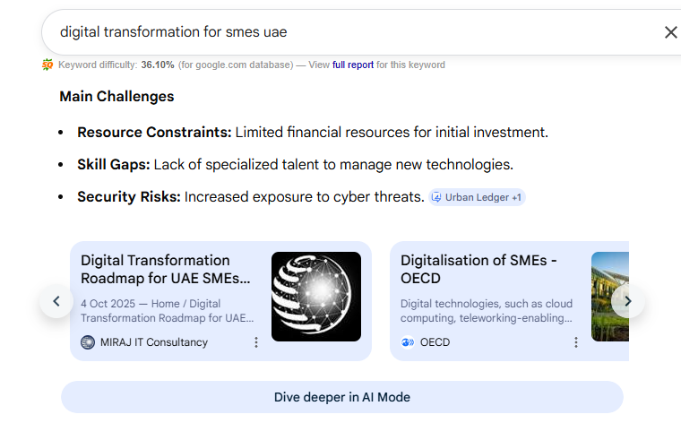

11.We are ranking on the google on ”73st” place for the keyword “digital business strategy uae”

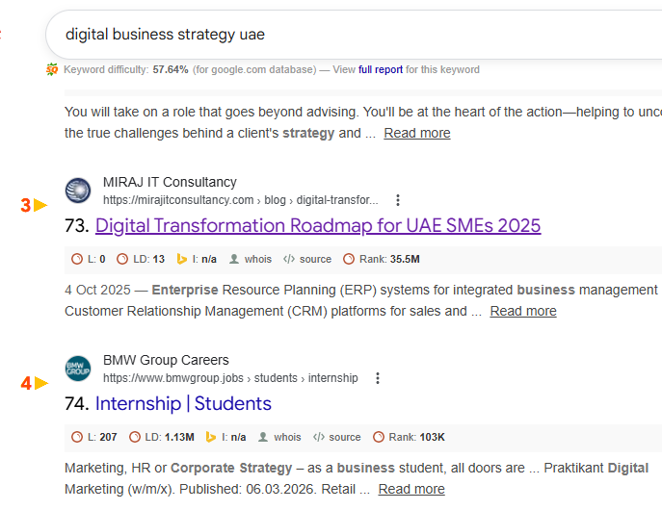
12.We are ranking on the google on ”33r” place for the keyword “digital transformation challenges smes uae”
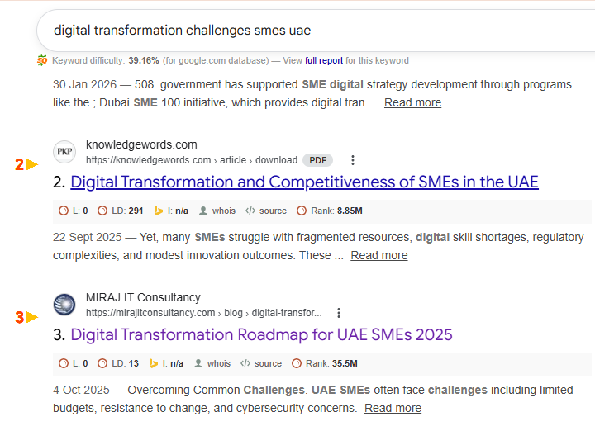

13.We are ranking on the google on ”56th” place for the keyword “social media marketing cost in dubai”
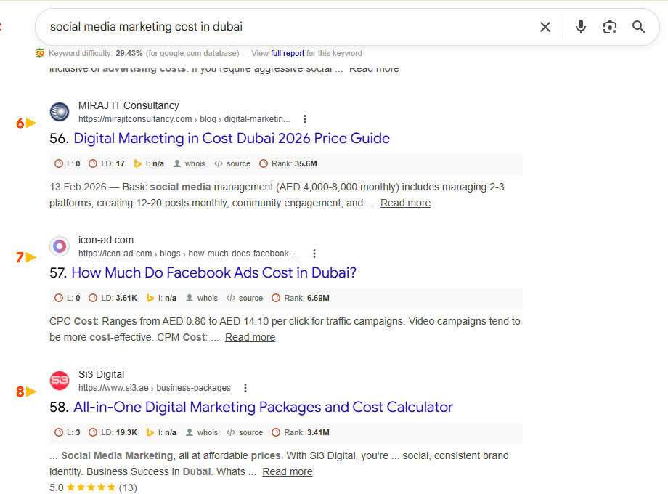

14.We are ranking on the google on ”11th” place for the keyword “digital transformation for smes uae”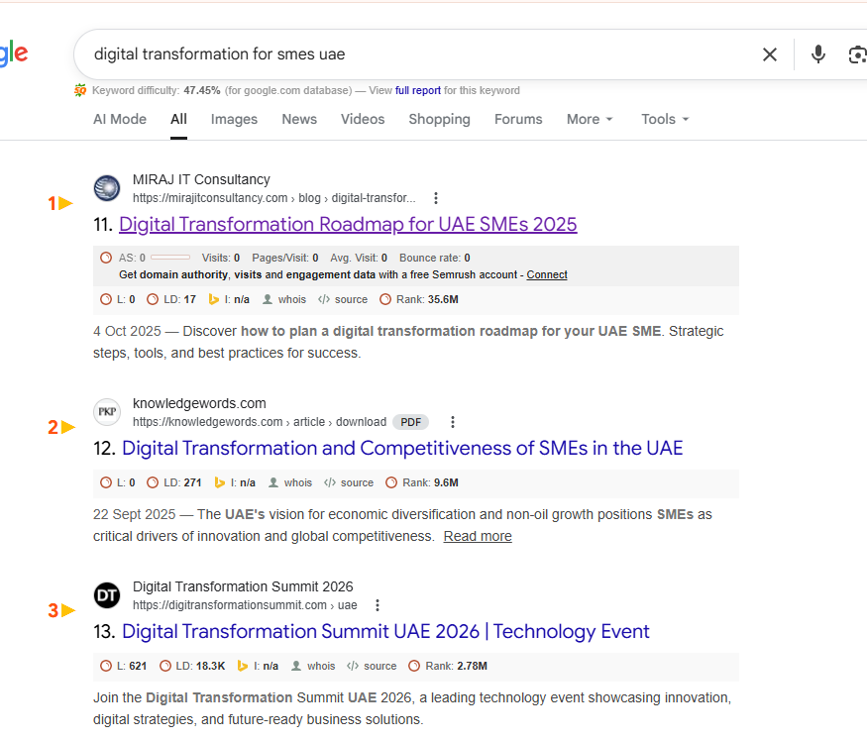

15.We are ranking on the google on ”15th” place for the keyword “ Dubai digital marketing”
